# QUESTION 1

You are given a task a lecturer at your college to write a complete program which will allow the user to calculate Salary Increase

The area formula is:

*Salary Increase = (Increase/100*Salary) + Salary*

**BELOW IS THE GRAPHIC USER INTERFACE (GUI) DIAGRAM**

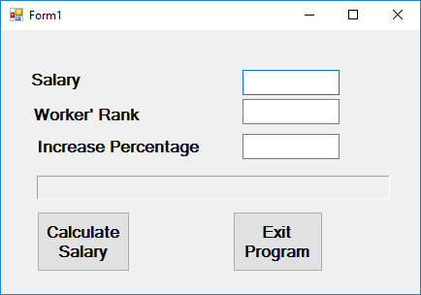

**BELOW IS THE UNIFIED MODELLING LANGUAGE (UML) DIAGRAM**

Salary

-Increase

-WorkerRank

-Salary

+SalaryIncrease()